**Marathwada Shikshan Prasarak Mandal’s**

**R.B. Attal Arts, Science & Commerce Collage, Georai, Dist. Beed.**

Department Of Computer Science

CERTIFICATE



This is certify that, **MR**. **ROHAN BHAKTPRALHAD MAGAR** A STUDENT OF **B.Sc.TY**, HAS prepared project on topic “CLOTH STORE” satisfactorily as per requirement of Dr. Babasaheb Ambedkar Marathwada University, Aurangabad in academic YEAR **2023-2024.**

**Examination Seat No. Date: / /2024**

**Guided By Principal**

**Examiner**

INDEX

|  |  |  |
| --- | --- | --- |
| **S. R** | **TABLE OF CONTENTS** | **Page No.** |
| 1 | Introduction |  |
| 2. | Purpose |  |
| 3. | Scope |  |
| 4. | Definition |  |
| 5. | Objective |  |
| 6. | Software Used |  |
| 7. | Data Flow Diagram |  |
| 8. | Table Form Design |  |
| 9. | E R Diagram |  |
| 10. | Design |  |
| 11. | File Structure |  |
| 12. | Coding |  |
| 13. | Outputs |  |
| 14. | Conclusion |  |
|  | Reference |  |
|  |  |  |

**Acknowledgement**

In the journey of creating the Online Cloth Store, we, the creators of this project - Mr. Rohan Bhaktpralhad Magar, Mr. Dinesh Parmeshwar Shinde, and Mr. Akshay Anil Borade - extend our heartfelt gratitude to Dr. Janwale Sir. His generous provision of this opportunity has ignited our passion and guided us through every step of development.

Dr. Janwale Sir's mentorship, expertise, and unwavering encouragement have been instrumental in shaping our project. His belief in our capabilities has motivated us to strive for excellence in every aspect.

Together, as creators of the Online Cloth Store, we acknowledge the invaluable contributions of Dr. Janwale Sir. His support, coupled with our collective efforts and dedication, has brought this project to fruition.

This project stands as a testament to the collaborative spirit and shared vision of Dr. Janwale Sir and us, the creators. We are deeply grateful for his guidance and inspiration throughout this journey.

**Preface**

Welcome to the Online Cloth Store project. As the creators of this endeavor, Mr. Rohan Bhaktpralhad Magar, Mr. Dinesh Parmeshwar Shinde, and Mr. Akshay Anil Borade, we are thrilled to present our collective efforts in establishing an innovative platform for online shopping enthusiasts.

The idea behind the Online Cloth Store was born from a shared passion for technology and fashion. Recognizing the growing trend of online shopping and the evolving needs of consumers, we set out to create a user-friendly and immersive experience for purchasing clothing items from the comfort of one's home.

Throughout the development process, we have been fortunate to receive invaluable guidance and support from Dr. Janwale Sir. His expertise and encouragement have been instrumental in shaping our vision and refining our approach towards building this platform.

This project represents a culmination of our dedication, creativity, and collaborative spirit. We hope that the Online Cloth Store will not only simplify the shopping experience but also inspire confidence and satisfaction among our users.

We extend our heartfelt gratitude to everyone who has contributed to the realization of this project, and we invite you to explore the Online Cloth Store and embark on a seamless journey of discovering your style.

**Introduction:**

Welcome to the Online Cloth Store, where fashion meets convenience in an unparalleled online shopping experience. Founded by a team driven by passion for both technology and style, we have crafted a platform dedicated to delivering the latest trends and timeless classics directly to your doorstep.

At the Online Cloth Store, we pride ourselves on offering a vast selection of clothing items to suit every taste and occasion. From casual wear to formal attire, our extensive collection ensures that there's something for everyone. We believe that fashion should be accessible to all, and with our user-friendly interface, browsing and purchasing your favorite pieces has never been easier.

As inventors of this innovative platform, we are committed to staying ahead of the curve, constantly updating our inventory with the latest styles and incorporating cutting-edge features to enhance your shopping experience. With secure payment options and seamless navigation, we strive to make your online shopping journey as smooth and enjoyable as possible.

Join us as we embark on this exciting venture to redefine the way you shop for clothing online. Thank you for choosing the Online Cloth Store. Happy shopping!

We invite you to explore our vast collection of clothing items, curated to cater to a diverse range of preferences and sizes. Whether you're looking for the perfect outfit for a special occasion, updating your wardrobe with the latest trends, or searching for unique accessories to elevate your look, we have you covered.

Our team of dedicated fashion enthusiasts is here to provide you with exceptional customer service every step of the way. From personalized recommendations to timely assistance, we are committed to ensuring that your shopping experience with us is nothing short of extraordinary.

At the Online Cloth Store, we understand that style is more than just clothing—it's a form of self-expression. That's why we strive to offer a diverse range of brands and styles, empowering you to embrace your individuality and express yourself through fashion.

Join the Online Cloth Store community today and discover a world of endless style possibilities. Thank you for choosing us as your go-to destination for all your clothing needs. Happy shopping!

**Purpose**

Project Purpose: Clothing Store Website

Objective:

The objective of this project is to design and develop a fully functional website for a clothing store. The website aims to provide an engaging and user-friendly online platform for customers to browse, select, and purchase clothing items.

Key Features:

1. Navigation Bar:c

- The navigation bar facilitates easy navigation throughout the website, allowing users to access different sections such as home, product categories, about us, contact, and possibly a blog.

2. Hero Carousel:

- The hero carousel serves as the focal point of the homepage, showcasing featured products or promotions with visually appealing images and compelling call-to-action buttons to encourage user engagement.

3. Product Listings:

- Product listings are organized into categories and collections, presenting a wide range of clothing items for men, women, and accessories. Each product card includes an image, name, price, and a "Shop Now" button for direct purchasing.

4. New Arrivals Section:

- This section highlights new arrivals from established brands, enticing customers to explore the latest trends and additions to the store's inventory.

5. Brand Showcase:

- The brand showcase section displays logos or images of renowned clothing brands carried by the store, reinforcing credibility and attracting brand-conscious customers.

6. Blog Excerpts:

- The blog excerpts section provides snippets of informative or entertaining content from the store's blog, enhancing user engagement and offering valuable insights related to fashion trends, styling tips, and industry news.

7. Footer:

- The footer contains essential links such as contact information, shipping details, privacy policy, terms of service, and social media links. It serves as a navigational aid and provides users with additional information about the store.

Overall Purpose:

The purpose of this project is to create an aesthetically pleasing, user-friendly, and feature-rich website for a clothing store. By offering a seamless online shopping experience, the website aims to attract customers, drive sales, and establish the brand as a trusted destination for fashion enthusiasts.

**Scope**

Project Scope: Clothing Store Website

Scope Definition:

The scope of this project encompasses the design and development of a fully functional e-commerce website for a clothing store. The website will provide an online platform for customers to browse, select, and purchase clothing items conveniently.

Key Components:

1. Website Design:

- Designing a visually appealing and user-friendly interface that reflects the brand identity and enhances the shopping experience.

- Creating responsive layouts to ensure compatibility across various devices and screen sizes.

2. Frontend Development:

- Implementing frontend functionalities such as navigation menus, product carousels, image galleries, and interactive elements using HTML, CSS, and JavaScript.

- Integrating third-party libraries and frameworks for enhanced features and performance optimization.

3. Backend Development:

- Developing backend functionalities for user authentication, product management, order processing, and payment gateway integration using suitable technologies such as Node.js, Django, or Laravel.

- Implementing a secure and scalable database system to store user data, product information, and transaction records.

4. E-commerce Features:

- Implementing features like product search, sorting, filtering, and pagination to enhance the browsing experience.

- Integrating a shopping cart system to allow users to add/remove items, view order summary, and proceed to checkout seamlessly.

- Implementing secure payment processing mechanisms, such as credit/debit card payments, PayPal, or other popular payment gateways.

5. Content Management:

- Providing an intuitive content management system (CMS) for store administrators to manage product listings, update inventory, and create/edit promotional content.

- Implementing blogging capabilities to publish articles, news, and fashion tips for customer engagement and SEO benefits.

6. Testing and Quality Assurance:

- Conducting comprehensive testing to ensure the website's functionality, performance, and security meet industry standards and user expectations.

- Performing usability testing to identify and address any usability issues or user experience improvements.

7. Deployment and Maintenance:

- Deploying the website to a reliable web hosting platform and configuring domain settings for live accessibility.

- Providing ongoing maintenance and support services to address any bugs, security vulnerabilities, or performance issues post-launch.

Deliverables:

- Fully functional e-commerce website with user-friendly frontend interface and robust backend functionalities.

- Admin dashboard for managing products, orders, and content.

- Secure payment gateway integration for online transactions.

- Responsive design for optimal viewing across desktop, tablet, and mobile devices.

Timeline:

The estimated timeline for completing this project is [insert estimated timeline here], including design, development, testing, and deployment phases.

Budget:

The project budget will depend on the complexity of features, technology stack, and scope adjustments. A detailed cost estimate will be provided upon project initiation.

**Definition**

Project Definition: Clothing Store Website Development

Project Name: Clothing Store Website

Project Description:

The Clothing Store Website project involves the design and development of an e-commerce website for a clothing store. The website aims to provide customers with an online platform to browse, select, and purchase clothing items conveniently. The project includes frontend and backend development, integration of e-commerce features, content management, testing, deployment, and ongoing maintenance.

Key Objectives:

1. To create a visually appealing and user-friendly interface for the clothing store website.

2. To develop frontend and backend functionalities for seamless navigation, product browsing, and online transactions.

3. To integrate essential e-commerce features such as product search, shopping cart, and secure payment processing.

4. To implement a content management system for managing product listings, inventory, and promotional content.

5. To conduct comprehensive testing to ensure the website's functionality, performance, and security meet industry standards.

6. To deploy the website to a reliable hosting platform and provide ongoing maintenance and support services.

Scope:

The scope of the project includes:

- Website design and development

- Frontend and backend development

- Integration of e-commerce features

- Content management system implementation

- Testing and quality assurance

- Deployment and maintenance

Deliverables:

1. Fully functional e-commerce website with a user-friendly interface.

2. Admin dashboard for managing products, orders, and content.

3. Secure payment gateway integration for online transactions.

4. Responsive design for optimal viewing across devices.

5. Comprehensive documentation of project specifications, features, and functionalities.

Timeline:

The estimated timeline for completing the project is [insert estimated timeline here], including design, development, testing, deployment, and maintenance phases.

Budget:

The project budget will depend on the scope of work, technology requirements, and any additional features or customizations. A detailed cost estimate will be provided upon project initiation.

Project Stakeholders:

- Project Manager

- Web Developers

- Designers

- Content Creators

- Quality Assurance Team

- Hosting Provider

- Client Representatives

Risks:

Potential risks associated with the project include:

- Delays in development due to unforeseen technical challenges.

- Compatibility issues across different browsers and devices.

- Security vulnerabilities leading to data breaches or unauthorized access.

- Budget overruns due to scope creep or changes in project requirements.

Mitigation strategies will be implemented to address these risks and ensure the successful completion of the project.

**Objective**

Project Objective: Clothing Store Website Development

Objective:

The objective of the Clothing Store Website project is to design, develop, and deploy an e-commerce website for a clothing store. The website aims to provide an online platform for customers to browse, select, and purchase clothing items conveniently. The key objectives of the project include:

1. Enhancing Customer Experience: Create a visually appealing and user-friendly interface that enables customers to navigate through the website seamlessly, view product details, and make purchases effortlessly.

2. Expanding Market Reach: Establish an online presence for the clothing store to reach a wider audience beyond the physical location, thereby increasing brand visibility and attracting new customers.

3. Increasing Sales Revenue: Provide customers with a convenient and secure platform to shop for clothing items, leading to an increase in sales revenue for the store.

4. Improving Operational Efficiency: Implement backend functionalities for inventory management, order processing, and customer relationship management to streamline business operations and enhance efficiency.

5. Establishing Brand Identity: Develop a website that reflects the brand identity and values of the clothing store, reinforcing its position in the market and building trust among customers.

6. Providing Ongoing Support: Deploy the website on a reliable hosting platform and provide ongoing maintenance and support services to ensure optimal performance and customer satisfaction.

By achieving these objectives, the Clothing Store Website project aims to create a successful online presence for the clothing store, driving growth and success in the competitive retail market.

**Software Used in the Project:**

1. Text Editor: Used a text editor (e.g., Visual Studio Code, Sublime Text, Atom) for writing and editing HTML, CSS, JavaScript, and other code files.

2. Web Browser: Used a web browser (e.g., Google Chrome, Mozilla Firefox, Safari) for testing and previewing the website during development.

3. Version Control System: Utilized a version control system (e.g., Git) for tracking changes to the project codebase, collaborating with team members, and managing project versions.

4. Design Software: Used design software (e.g., Adobe Photoshop, Adobe XD, Sketch) for creating mockups, wireframes, and design elements for the website layout and user interface.

5. Image Editing Software: Utilized image editing software (e.g., Adobe Photoshop, GIMP) for editing and optimizing images used in the website design and content.

6. Integrated Development Environment (IDE): Used an IDE (e.g., Visual Studio Code, WebStorm) for code development, debugging, and project management tasks.

7. Package Manager: Utilized a package manager (e.g., npm, yarn) for installing and managing third-party libraries, frameworks, and dependencies used in the project.

8. Web Development Frameworks/Libraries: Used web development frameworks and libraries (e.g., Bootstrap, jQuery) for accelerating development, implementing responsive design, and adding interactive features to the website.

9. Deployment Tools: Employed deployment tools (e.g., FTP clients, hosting platforms like AWS, Heroku, Netlify) for deploying the website to a live server and making it accessible to users.

10. Content Management System (CMS): Depending on project requirements, a CMS (e.g., WordPress, Shopify) may have been used for managing website content, product listings, and blog posts.

11. Collaboration Tools: Used collaboration tools (e.g., Slack, Microsoft Teams, Trello) for communication, task management, and project coordination among team members.

12. Testing Tools: Employed testing tools (e.g., Google PageSpeed Insights, Lighthouse, Browser Developer Tools) for evaluating website performance, responsiveness, and compatibility across different devices and browsers.

By utilizing these software tools and technologies, the project team was able to effectively design, develop, and deploy the Clothing Store Website according to the project requirements and objectives.

**Data Flow Diagram (DFD) Overview:**

A Data Flow Diagram (DFD) is a graphical representation of the flow of data within a system. It illustrates how data moves between processes, data stores, and external entities. DFDs are commonly used in systems analysis and design to understand and document the structure and behavior of a system.

Components of a DFD:

1. External Entities:

- External entities represent sources or destinations of data outside the system being modeled. They interact with the system by sending or receiving data.

- Examples include users, customers, suppliers, or other systems.

2. Processes:

- Processes represent activities or transformations that occur within the system. They describe how data is manipulated, transformed, or generated.

- Each process in a DFD receives input data, performs some processing, and produces output data.

- Processes are typically represented by circles or ovals in a DFD.

3. Data Stores:

- Data stores represent repositories of data within the system. They store data persistently and provide storage for information used by processes.

- Examples include databases, files, or other storage systems.

- Data stores are typically represented by rectangles in a DFD.

4. Data Flows:

- Data flows represent the movement of data between processes, data stores, and external entities in the system.

- They illustrate the flow of information and show how data is passed from one component to another.

- Data flows are typically represented by arrows in a DFD, indicating the direction of data movement.

Levels of DFDs:

1. Context Level DFD:

- The highest level of abstraction in a DFD.

- Provides an overview of the entire system, showing interactions between the system and external entities.

- Includes only one process representing the entire system.

2. Level 0 DFD:

- The next level of detail below the context level.

- Decomposes the system into major processes and data stores.

- Shows the main processes and their interactions with external entities and data stores.

3. Lower-Level DFDs:

- Further decompose processes into sub-processes and data stores into smaller components.

- Provide more detailed views of specific parts of the system.

- Help to clarify complex processes and data flows.

Purpose of DFDs:

- DFDs help to visualize and understand the flow of data within a system.

- They aid in system analysis, design, and documentation.

- DFDs facilitate communication between stakeholders by providing a common language for discussing system requirements and functionality.

- They serve as a basis for system implementation, testing, and maintenance.

Creating a DFD:

- To create a DFD, identify the main components of the system, including external entities, processes, data stores, and data flows.

- Start with a context level DFD to provide an overview of the system's interactions with external entities.

- Decompose the context level DFD into lower-level DFDs to provide more detailed views of the system's processes and data flows.

- Use standardized symbols and notation to represent components and connections in the DFD.

**Table Form Design :**

**B**

LOGO

LOGO

LOGO

LOGO

LOGO

IMG

IMG

IMG

diagram

IMG

TEXT

IMG

TEXT

IMG

TEXT

IMG

TEXT

IMG

IMG

IMG

IMG

HERO SECTION

Title Pages

IMG

IMG

IMG

IMG

IMG

IMG

Title Pages

IMG

IMG

IMG

IMG

IMG

IMG

Footer

BUTTON

BUTTON

INPUT PASS

INPUT ID

[Grab your reader’s attention with a great quote from the document or use this space to emphasize a key point. To place this text box anywhere on the page, just drag it.]

TITLE FORM

SIGN UP BUTTON

[Grab your reader’s attention with a great quote from the document or use this space to emphasize a key point. To place this text box anywhere on the page, just drag it.]

TITLE FORM

MY ACCOUNT

**Entity-Relationship (ER) Diagram Overview:**

The ER diagram for the Cloth Store Management System depicts the structure of the database used to manage various aspects of the store's operations. It visualizes the entities, attributes, and relationships involved in the system, providing a clear understanding of how data is organized and related.

Components of the ER Diagram:

1. Entities:

- Customer: Represents individuals who make purchases at the cloth store.

- Product: Represents the items available for sale in the store, such as clothing, accessories, etc.

- Order: Represents the purchase transactions made by customers.

- Category: Represents the categories or types of products available in the store.

2. Attributes:

- Customer:

- CustomerID: Unique identifier for each customer.

- Name: Name of the customer.

- Email: Email address of the customer.

- Address: Customer's residential address.

- Product:

- ProductID: Unique identifier for each product.

- Name: Name or description of the product.

- Price: Price of the product.

- Stock: Quantity of the product available in the store.

- Order:

- OrderID: Unique identifier for each order.

- CustomerID: Foreign key referencing the customer placing the order.

- Date: Date and time when the order was placed.

- TotalAmount: Total amount of the order.

- Category:

- CategoryID: Unique identifier for each category.

- Name: Name or description of the category.

3. Relationships:

- Customer places Order: Represents the association between customers and their orders.

- Product belongs to Category: Describes the relationship between products and their categories.

- Order contains Product: Indicates the products included in each order.

Purpose of the ER Diagram:

- The ER diagram serves as a blueprint for designing and implementing the database schema for the Cloth Store Management System.

- It helps stakeholders understand the structure and relationships of the data model, facilitating communication and collaboration among designers, developers, and end-users.

- The ER diagram guides the creation of database tables, relationships, and constraints, ensuring the efficient management of store operations and data.

Creating the ER Diagram:

- The ER diagram was created using standard notation and symbols, including rectangles for entities, ovals for attributes, and diamond shapes for relationships.

- Each entity was identified along with its attributes, and relationships between entities were established based on the business requirements of the cloth store management system.

Data Base

User

Process

Home page  
Home

Shop

New In

Profile

Wishlist

Cart br

Data Base

User

Process

Home

Reload Home Page

Data Base

User

Process

Shop

It will be Added to The Cart.

Data Base

User

Process

New In

It will show the Option for the filter

Data Base

User

Process

Profile

Login Page

Sign Up Page

Data Base

User

Process

Cart Bar

Page of baught items

Data Base

User

Process

Wishlist

Wished Items Page

Data Base

User

Process

Cart Page

Increament

Remove

Either Remove Or Add Item

**Design Overview:**

The design of the Cloth Store Management System encompasses various components and considerations to ensure the system's functionality, usability, and scalability. It involves the architecture, user interface design, database design, and overall system flow.

Components of the Design:

1. Architecture:

- The system follows a client-server architecture, where clients interact with a web-based interface to browse products, place orders, and manage their accounts.

- The server-side application manages the database interactions, business logic, and processing of requests from clients.

- The use of a web-based architecture allows for platform-independent access and easy scalability.

2. User Interface Design:

- The user interface is designed to be intuitive, visually appealing, and responsive across various devices and screen sizes.

- Navigation elements, such as menus and search bars, are strategically placed for easy access to different sections of the application.

- Product listings are displayed with clear images, descriptions, and pricing information to assist users in making informed purchase decisions.

- Checkout processes are streamlined, with options for guest checkout or account registration to enhance user experience.

3. Database Design:

- The database schema is designed to efficiently store and manage data related to customers, products, orders, and categories.

- Proper indexing and normalization techniques are employed to optimize query performance and ensure data integrity.

- Relationships between entities are defined using foreign keys, establishing associations and maintaining data consistency.

- Security measures, such as encryption and access control, are implemented to protect sensitive customer information and prevent unauthorized access.

4. System Flow:

- The system flow begins with the user browsing products, either by category or search functionality.

- Users can view product details, add items to their shopping cart, and proceed to checkout.

- During checkout, users provide shipping and payment information, and the order is processed.

- Order status updates and notifications are provided to users via email or through the application interface.

- Administrative features allow store managers to manage products, view orders, and analyze sales data for business insights.

Purpose of the Design:

- The design aims to provide a seamless and enjoyable shopping experience for customers while offering efficient management tools for store administrators.

- It ensures the reliability, scalability, and maintainability of the system, allowing for future enhancements and updates as needed.

- By focusing on usability and performance, the design aims to increase customer satisfaction, drive sales, and optimize business operations for the cloth store.

Creating the Design:

- The design process involved collaboration between designers, developers, and stakeholders to gather requirements, define features, and create wireframes and mockups.

- Iterative prototyping and user testing were conducted to refine the design and address usability issues.

- The final design incorporates best practices in web development, user experience design, and database management to deliver a robust and user-friendly cloth store management system.

**Home :**

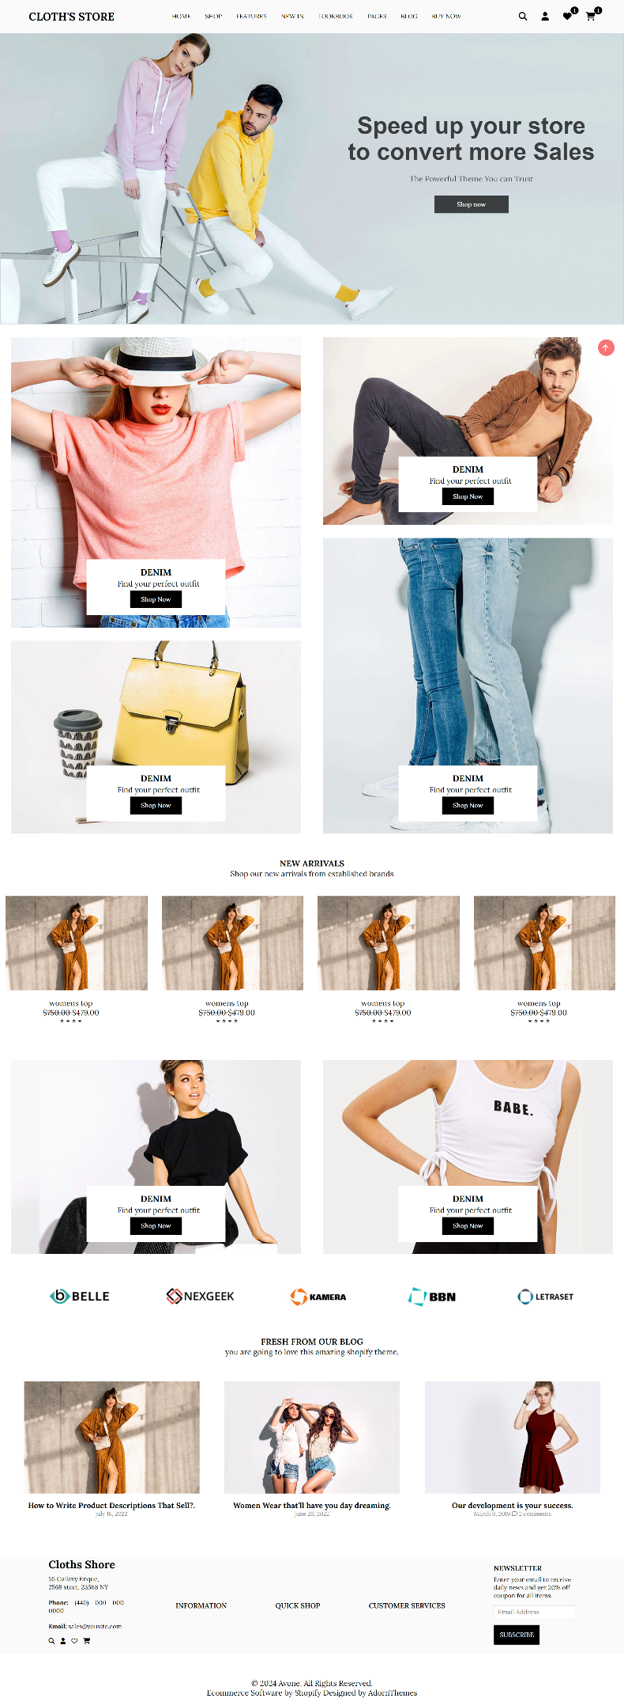

**Cart Design :**

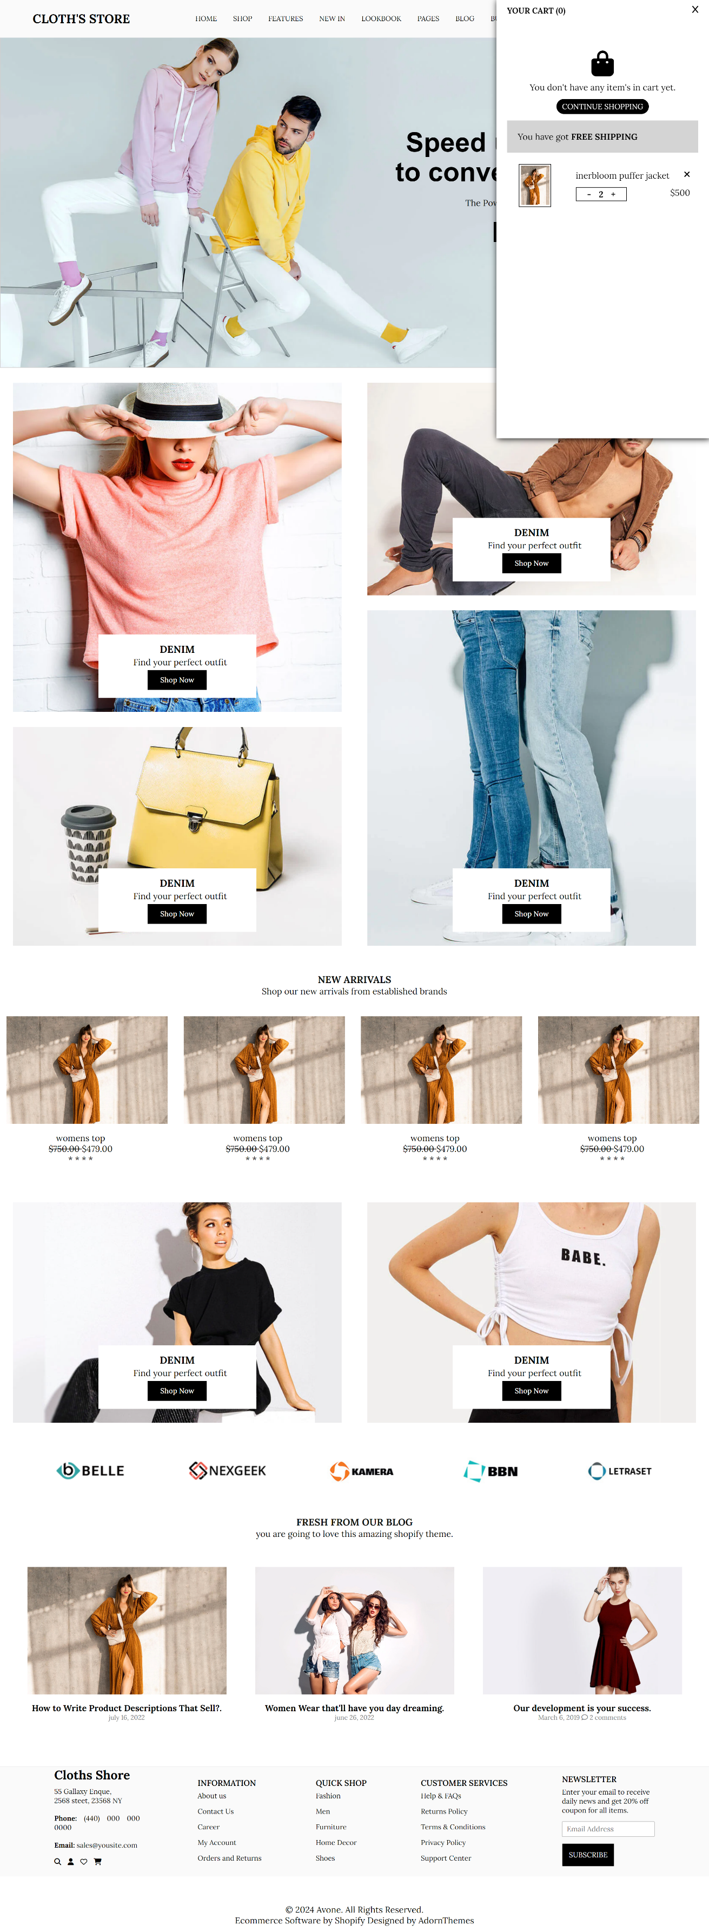

**Shop Desing :**

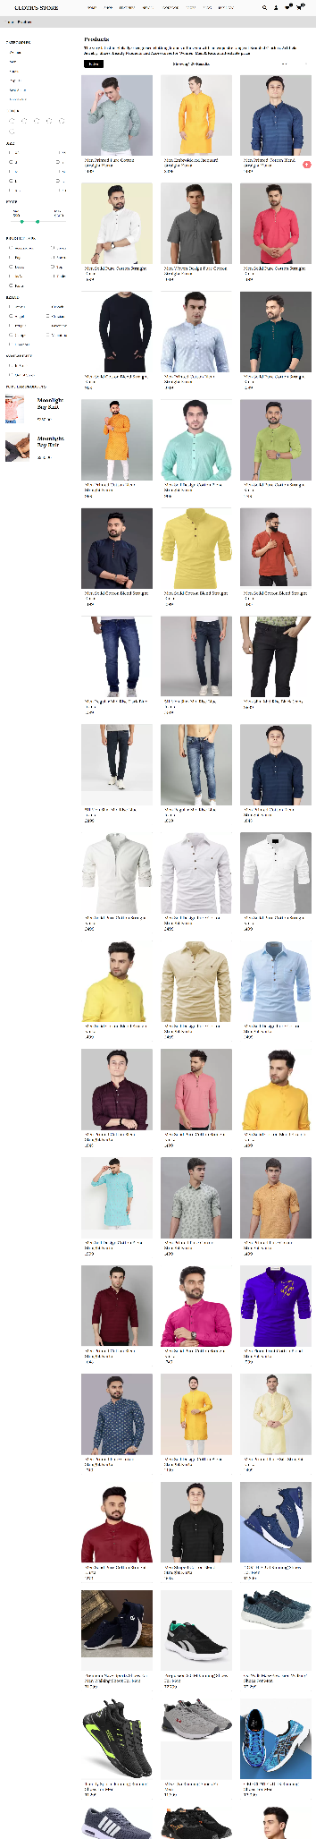

**Wishlist Design :**

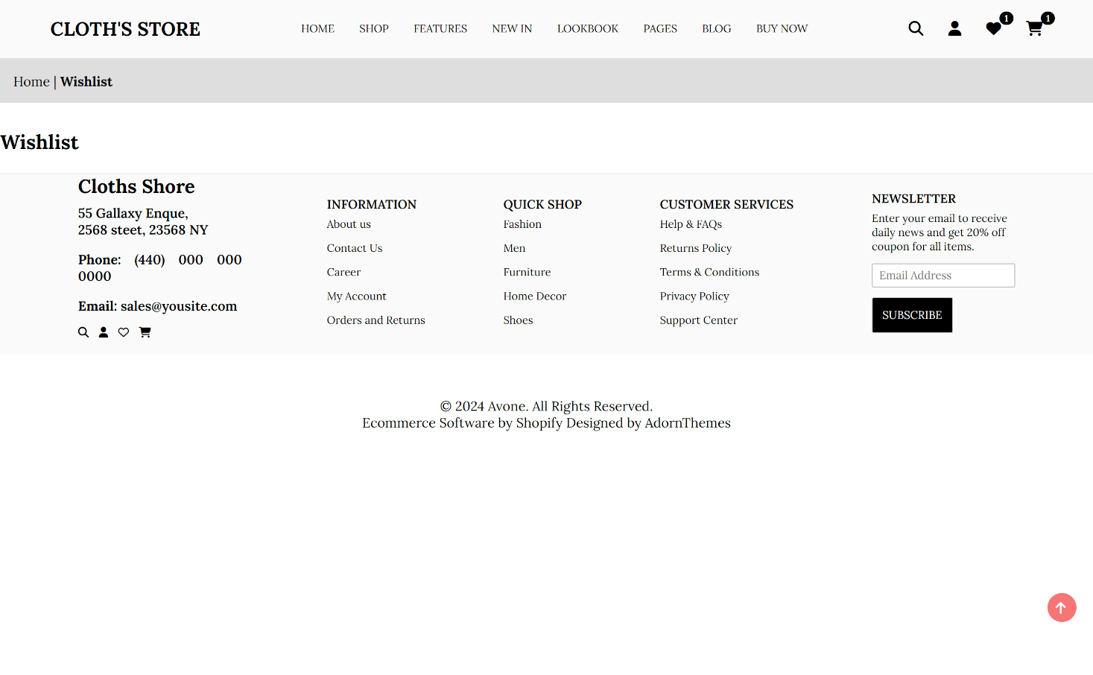

**Mobile & iPad Responsive Design :**

**Home :**

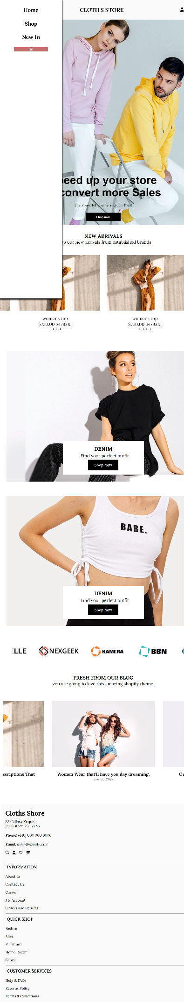

**Cart Bar :**

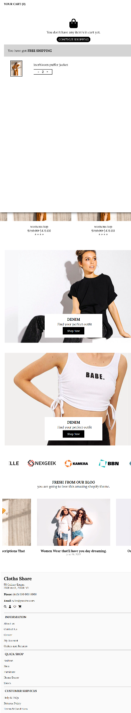

**Best Seller :**



**Shop:**



**File Structure :**

Cloth- Store

assets

Blog img

Brand

Card

Product.mini.css

CSS

style.min.css

Cart.js

JS

Footer.js

Product.min.js

Header.js

Script.min.js

Script.js

pages

Collections.html

Footer.html

Header.html

Product.html

Woman.html

**Coding :**

**Index.html**<!DOCTYPE html>

<html lang="en">

<head>

<meta charset="UTF-8">

<meta name="viewport" content="width=device-width, initial-scale=1.0">

<title>Cloth Store</title>

<link rel="stylesheet" href="https://cdnjs.cloudflare.com/ajax/libs/font-awesome/6.5.1/css/all.min.css"

integrity="sha512-DTOQO9RWCH3ppGqcWaEA1BIZOC6xxalwEsw9c2QQeAIftl+Vegovlnee1c9QX4TctnWMn13TZye+giMm8e2LwA=="

crossorigin="anonymous" referrerpolicy="no-referrer" />

<link rel="stylesheet" href="css/style.min.css">

<script src="https://code.jquery.com/jquery-3.7.1.js"

integrity="sha256-eKhayi8LEQwp4NKxN+CfCh+3qOVUtJn3QNZ0TciWLP4=" crossorigin="anonymous"></script>

</head>

<body>

<header class="navbar" id="nav-bar">Connect internet show navbar</header>

<main>

<section class="hero-cerosol">

<div class="slider">

<div class="mySlides">

<img src="./asset/carousal/dome1-bnr1_1600x.webp" class="img-size" alt="">

<img src="./asset/carousal/default-mb-bnr1_700x.jpg" class="sm-img-size-2" alt="">

<div class="text-box">

<div class="ss_txt fade">

<h2 class="ft2">

Speed up your store<br> to convert more Sales

</h2>

<div class="stxt hd3 ft1 hide-sm ">

The Powerful Theme You can Trust

</div>

<div class="btnWrap">

<button class="btn">Shop now</button>

</div>

</div>

</div>

</div>

<div class="mySlides ">

<img src="./asset/carousal/dome1-bnr2_2000x.webp" class="img-size-2" alt="">

<img src="./asset/carousal/default-mb-bnr2_1400x.jpg" class="sm-img-size-2" alt="">

<div class="text-box-2">

<div class="ss_txt fade">

<h2 class="ft2">

Speed up your store<br> to convert more Sales

</h2>

<div class="stxt hd3 ft1 hide-sm ">

The Powerful Theme You can Trust

</div>

<div class="btnWrap">

<button class="btn">Shop now</button>

</div>

</div>

</div>

</div>

</div>

</section>

<section class="hero-product" id="hide-product">

<div class="hero-product-hov ">

<div class="hero-left">

<div class="hero-card">

<img src="./asset/card/womens-top_770x.webp" alt="">

<div class="fl cldtl_wrap f-jcc f-aie">

<div class="details-bx">

<h3 class="clitem-ttl"> DENIM</h3>

<p>Find your perfect outfit</p>

<button class="btn" type="button">Shop Now</button>

</div>

</div>

</div>

<div class="hero-card">

<img src="./asset/card/accesories_770x.webp" alt="">

<div class="fl cldtl_wrap f-jcc f-aie">

<div class="details-bx">

<h3 class="clitem-ttl"> DENIM</h3>

<p>Find your perfect outfit</p>

<button class="btn" type="button">Shop Now</button>

</div>

</div>

</div>

</div>

<div class="hero-right">

<div class="hero-card">

<img src="./asset/card/men-clothing_770x.webp" alt="">

<div class="fl cldtl_wrap f-jcc f-aie">

<div class="details-bx">

<h3 class="clitem-ttl"> DENIM</h3>

<p>Find your perfect outfit</p>

<button class="btn" type="button">Shop Now</button>

</div>

</div>

</div>

<div class="hero-card">

<img src="./asset/card/denim.webp" alt="">

<div class="fl cldtl_wrap f-jcc f-aie">

<div class="details-bx">

<h3 class="clitem-ttl"> DENIM</h3>

<p>Find your perfect outfit</p>

<button class="btn" type="button">Shop Now</button>

</div>

</div>

</div>

</div>

</div>

</section>

<section class="hero-product-card">

<div class="sec-ttl tc">

<h2 class="h3 ft2"><b>NEW ARRIVALS</b></h2>

<p>Shop our new arrivals from established brands</p>

</div>

<div class="container-card">

<div class="card-main">

<div class="img-div">

<img src="./asset/blog-images/blocg-img-1.jpg" alt="Card Image">

<div class="buy-span">

<ul class="flex">

<li><a href="#"><i class="fa-solid fa-heart"></i></a></li>

<li><a href="#"><i class="fa-solid fa-cart-shopping"></i></a></li>

</ul>

</div>

</div>

<div class="details-card">

<p>Womens top</p>

<p class="price-text"><s>$750.00</s><span>$479.00</span></p>

<p class="price-text"> * * * * </p>

</div>

</div>

<div class="card-main">

<div class="img-div">

<img src="./asset/blog-images/blocg-img-1.jpg" alt="Card Image">

<div class="buy-span">

<ul class="flex">

<li><a href="#"><i class="fa-solid fa-heart"></i></a></li>

<li><a href="#"><i class="fa-solid fa-cart-shopping"></i></a></li>

</ul>

</div>

</div>

<div class="details-card">

<p>Womens top</p>

<p class="price-text"><s>$750.00</s><span>$479.00</span></p> <p class="price-text"> * * * * </p>

</div>

</div>

<div class="card-main">

<div class="img-div">

<img src="./asset/blog-images/blocg-img-1.jpg" alt="Card Image">

<div class="buy-span">

<ul class="flex">

<li><a href="#"><i class="fa-solid fa-heart"></i></a></li>

<li><a href="#"><i class="fa-solid fa-cart-shopping"></i></a></li>

</ul>

</div>

</div>

<div class="details-card">

<p>Womens top</p>

<p class="price-text"><s>$750.00</s><span>$479.00</span></p>

<p class="price-text"> * * * * </p>

</div>

</div>

<div class="card-main">

<div class="img-div">

<img src="./asset/blog-images/blocg-img-1.jpg" alt="Card Image">

<div class="buy-span">

<ul class="flex">

<li><a href="#"><i class="fa-solid fa-heart"></i></a></li>

<li><a href="#"><i class="fa-solid fa-cart-shopping"></i></a></li>

</ul>

</div>

</div>

<div class="details-card">

<p>Womens top</p>

<p class="price-text"><s>$750.00</s><span>$479.00</span></p>

<p class="price-text"> * * * * </p>

</div>

</div>

<div class="card-main">

<div class="img-div">

<img src="./asset/blog-images/blocg-img-1.jpg" alt="Card Image">

<div class="buy-span">

<ul class="flex">

<li><a href="#"><i class="fa-solid fa-heart"></i></a></li>

<li><a href="#"><i class="fa-solid fa-cart-shopping"></i></a></li>

</ul>

</div>

</div>

<div class="details-card">

<p>Womens top</p>

<p class="price-text"><s>$750.00</s><span>$479.00</span></p>

<p class="price-text">* * * * </p>

</div>

</div>

</div>

</section>

<section class="hero-product">

<div class=" hero-product-hov ">

<div class="hero-right-1">

<div class="hero-card">

<img src="./asset/card/awesome-tops_1200x.jpg" alt="">

<div class="fl cldtl_wrap f-jcc f-aie">

<div class="details-bx">

<h3 class="clitem-ttl"> DENIM</h3>

<p>Find your perfect outfit</p>

<button class="btn" type="button">Shop Now</button>

</div>

</div>

</div>

<div class="hero-card">

<img src="./asset/card/best-collections_1200x.webp" alt="">

<div class="fl cldtl_wrap f-jcc f-aie">

<div class="details-bx">

<h3 class="clitem-ttl"> DENIM</h3>

<p>Find your perfect outfit</p>

<button class="btn" type="button">Shop Now</button>

</div>

</div>

</div>

</div>

</div>

</section>

<section class="brand-box">

<div class="brands">

<img src="asset/brand/item-1.png" alt="item-1">

<img src="asset/brand/item-2.png" alt="item-2">

<img src="asset/brand/item-3.png" alt="item-3">

<img src="asset/brand/item-4.png" alt="item-4">

<img src="asset/brand/item-5.png" alt="item-5">

</div>

</section>

<section class="Hero-Carousel-Product last-product-box">

<div class="sec-ttl tc">

<h2 class="h3 ft2"><b>FRESH FROM OUR BLOG </b></h2>

<p>You are going to love this amazing Shopify theme.</p>

</div>

<div class="l-products">

<div class="l-product">

<div class="l-product-img">

<img src="asset/blog-images/blocg-img-1.jpg" alt="blocg-img-1">

</div>

<div class="l-product-details">

<h4>How to Write Product Descriptions That Sell?</h4>

<p>July 16, 2022</p>

</div>

</div>

<div class="l-product">

<div class="l-product-img">

<img src="asset/blog-images/blocg-img-2.jpg" alt="blocg-img-1">

</div>

<div class="l-product-details">

<h4>Women Wear that'll have you day dreaming</h4>

<p>June 26, 2022</p>

</div>

</div>

<div class="l-product">

<div class="l-product-img">

<img src="asset/blog-images/blocg-img-3.jpg" alt="blocg-img-1">

</div>

<div class="l-product-details">

<h4>Our development is your success</h4>

<p>March 6, 2019 <span><a href=""><i class="fa-regular fa-comment"></i> 2 comments</a></span></p>

</div>

</div>

</div>

</section>

</main>

<footer class="footer" id="Footer">Footer</footer>

</body>

<script>

let slideIndex = 0;

showSlides();

function showSlides() {

let i;

let slides = document.getElementsByClassName("mySlides");

for (i = 0; i < slides.length; i++) {

slides[i].style.display = "none";

}

slideIndex++;

if (slideIndex > slides.length) { slideIndex = 1 }

slides[slideIndex - 1].style.display = "block";

setTimeout(showSlides, 6000); // Change image every 6 seconds

}

</script>

<script src="./js/script.min.js"></script>

<script> $("Footer").load("/page/footer.html"); $("#nav-bar").load("/page/header.html"); </script>

</html>

**Style.css**

@import url("https://fonts.googleapis.com/css2?family=Lora:wght@400;500;600;700&display=swap");

/* Global Styles */

* {

margin: 0;

padding: 0;

box-sizing: border-box;

font-family: "Lora", sans-serif; /* Updated font family */

}

/* Root Variables */

:root {

--white: #ffffff;

--white-25: #e5e5e5;

--white-50: #f5f5f5;

--white-55: #f6f6f6;

--black: #353535;

--black-25: #5b5b5b;

--border-5: 5px;

--padding-1: 1rem;

--padding-2: 2rem;

--padding-3: 3rem;

--margin-1: var(--padding-1);

--margin-2: var(--padding-2);

--margin-3: var(--padding-3);

}

/* Utility Classes */

li {

list-style: none;

}

.flex {

display: flex;

}

.spa-bet {

justify-content: space-between;

}

.spa-aro {

justify-content: space-around;

}

.align {

align-items: center;

}

.direc {

flex-direction: column;

}

.wrap {

flex-wrap: wrap;

}

a {

color: #000;

text-decoration: none;

}

/* Slider Styles */

.slider {

overflow: hidden;

width: 100%;

position: relative;

margin: auto;

}

.mySlides {

display: none;

}

.fade {

animation-name: fade;

animation-duration: 1.5s;

}

@keyframes fade {

from {

opacity: 0.4;

}

to {

opacity: 1;

}

}

.text-box,

.text-box-2 {

display: flex;

width: 616px;

height: 100%;

position: absolute;

top: 0;

align-items: center;

text-align: center;

padding: 0 2rem;

}

.text-box-2 {

right: 0;

}

.btnWrap {

width: 100%;

}

.btnWrap button {

width: 30%;

display: block;

margin: auto;

}

.hide-sm {

color: #000000;

font-size: 16px;

font-weight: 400;

line-height: 1.2;

margin-bottom: 25px;

text-align: center;

}

.btn {

font-weight: 500;

color: #fff;

padding: 9px 22px;

background: #000;

border: 1px solid black;

cursor: pointer;

}

.btn:hover {

color: #000;

background-color: #fff;

}

.ft2 {

color: #000000;

font-family: sans-serif;

font-size: 50px;

font-weight: 700;

line-height: 1.1;

margin-bottom: 20px;

}

.img-size,

.img-size-2 {

width: 100%;

border: 1.2px solid rgba(138, 136, 136, 0.4);

display: inline-block;

}

.sm-img-size-2 {

display: none;

}

@keyframes fadeIn {

0% {

opacity: 0;

}

100% {

opacity: 1;

transform: scale(1);

}

}

/* Responsive Styles */

@media screen and (max-width: 770px) {

.text-box,

.text-box-2 {

width: 100%;

justify-content: center;

align-items: end;

top: 34px;

}

.ss_txt {

padding: 2rem;

border-radius: 12px;

}

.img-size {

display: none;

}

.sm-img-size-2 {

display: inline-block;

height: 100%;

width: 100%;

}

.mySlides {

height: 80%;

}

#hide-product,

.img-size-2 {

display: none;

}

.hero-right-1 {

display: flex;

flex-wrap: wrap;

}

}

/* Hero Product Styles */

.hero-product-hov {

display: flex;

justify-content: center;

text-align: center;

width: 100%;

}

.slider {

padding-top: 4rem;

}

.hero-card {

overflow: hidden;

text-align: center;

margin: 1.5rem;

position: relative;

}

.hero-card img {

width: 100%;

object-fit: cover;

object-position: center;

transition: transform 0.5s ease;

}

.hero-card:hover img {

transform: scale(1.2);

}

.cldtl_wrap {

position: absolute;

top: 0;

left: 0;

right: 0;

bottom: 0;

padding: 20px 30px;

}

.f-aie {

align-items: flex-end;

}

.f-jcc {

justify-content: center;

}

.fl,

.flex {

display: flex;

}

.details-bx p {

margin: 2px 12px 5px 23px;

}

.details-bx {

padding: 15px 42px;

background-color: white;

}

/* Title Styles */

.sec-ttl {

padding-top: 25px;

padding-bottom: 25px;

overflow: hidden;

}

.tc {

text-align: center !important;

}

.sec-ttl .h3 {

color: #111;

font-weight: 700;

margin: 0 auto;

font-size: 18px;

}

/* Brand Styles */

.brand-box {

padding: 1rem;

margin: 0.75rem;

}

.brands {

display: flex;

width: 95%;

margin: auto;

justify-content: space-around;

overflow: auto;

gap: 2rem;

}

.container-card {

display: flex;

justify-content: center;

overflow: auto;

}

.card-main {

width: 700px;

height: 334px;

}

.img-div img {

object-fit: contain;

width: 300px;

margin: 12px;

width: 300px;

position: relative;

top: 0;

}

.img-div {

position: relative;

top: 0;

}

.buy-span {

position: absolute;

top: 16px;

right: 23px;

z-index: 1;

transition: all 0.19s ease;

opacity: 0;

}

.buy-span ul li {

padding: 5px;

}

.details-card {

display: flex;

flex-direction: column;

align-items: center;

width: 300px;

}

.img-div:hover .buy-span {

opacity: 1;

}

/* Last@import url("https://fonts.googleapis.com/css2?family=Lora:wght@400;500;600;700&display=swap");

/* Global Styles */

* {

margin: 0;

padding: 0;

box-sizing: border-box;

font-family: "Lora", sans-serif; /* Adjusted font family name */

}

/* Root Variables */

:root {

--white: #ffffff;

--white-25: #e5e5e5;

--white-50: #f5f5f5;

--white-55: #f6f6f6;

--black: #353535;

--black-25: #5b5b5b;

--border-5: 5px;

--padding-1: 1rem;

--padding-2: 2rem;

--padding-3: 3rem;

--margin-1: var(--padding-1);

--margin-2: var(--padding-2);

--margin-3: var(--padding-3);

}

/* Utilities */

li {

list-style: none;

}

.flex {

display: flex;

}

.spa-bet {

justify-content: space-between;

}

.spa-aro {

justify-content: space-around;

}

.align {

align-items: center;

}

.direc {

flex-direction: column;

}

.wrap {

flex-wrap: wrap;

}

a {

color: #000;

text-decoration: none;

}

/* Slider Styles */

.slider {

overflow: hidden;

width: 100%;

position: relative;

margin: auto;

padding-top: 4rem; /* Adjusted padding for slider */

}

.mySlides {

display: none;

}

.fade {

animation-name: fade;

animation-duration: 1.5s;

}

@keyframes fade {

from {

opacity: 0.4;

}

to {

opacity: 1;

}

}

.text-box,

.text-box-2 {

display: flex;

width: 616px;

height: 100%;

position: absolute;

top: 0;

left: 0;

align-items: center;

text-align: center;

padding: 0 2rem;

}

.text-box-2 {

right: 0;

}

.btnWrap {

width: 100%;

}

.btnWrap button {

width: 30%;

display: block;

margin: auto;

}

.hide-sm {

color: #000000;

font-size: 16px;

font-weight: 400;

line-height: 1.2;

margin-bottom: 25px;

text-align: center;

}

.btn {

font-weight: 500;

color: #fff;

padding: 9px 22px;

background: #000;

border: 1px solid black;

cursor: pointer;

}

.btn:hover {

color: #000;

background-color: #fff;

}

.fade {

animation: fadeIn ease-in 1s;

}

.ft2 {

color: #000000;

font-family: sans-serif;

font-size: 50px;

font-weight: 700;

line-height: 1.1;

margin-bottom: 20px;

}

.img-size,

.img-size-2 {

width: 100%;

border: 1.2px solid rgba(138, 136, 136, 0.4);

display: inline-block;

}

.sm-img-size-2 {

display: none;

}

@keyframes fadeIn {

0% {

opacity: 0;

}

100% {

opacity: 1;

transform: scale(1);

}

}

@media screen and (max-width: 770px) {

.text-box,

.text-box-2 {

width: 100%;

justify-content: center;

align-items: end;

top: 34px;

}

.ss_txt {

padding: 2rem;

border-radius: 12px;

}

.img-size {

display: none;

}

.sm-img-size-2 {

display: inline-block;

height: 100%;

width: 100%;

}

.mySlides {

height: 80%;

}

#hide-product {

display: none;

}

.hero-right-1 {

display: flex;

flex-wrap: wrap;

}

.img-size-2 {

display: none;

}

}

/* Product Card Styles */

.hero-card {

overflow: hidden;

text-align: center;

margin: 1.5rem;

position: relative;

}

.hero-card img {

width: 100%;

object-fit: cover;

object-position: center;

transition: transform 0.5s ease;

}

.hero-card:hover img {

transform: scale(1.2);

}

.cldtl_wrap {

position: absolute;

top: 0;

left: 0;

right: 0;

bottom: 0;

padding: 20px 30px;

}

.f-aie {

align-items: flex-end;

}

.f-jcc {

justify-content: center;

}

.details-bx p {

margin: 2px 12px 5px 23px;

}

.details-bx {

padding: 15px 42px;

background-color: white;

}

.sec-ttl {

padding-top: 25px;

padding-bottom: 25px;

overflow: hidden;

}

.tc {

text-align: center !important;

}

.sec-ttl .h3 {

color: #111;

font-weight: 700;

margin: 0 auto;

font-size: 18px;

}

/* Brand Styles */

.brand-box {

padding: 1rem;

margin: 0.75rem;

}

.brands {

display: flex;

width: 95%;

margin: auto;

justify-content: space-around;

overflow: auto;

gap: 2rem;

}

/* Container Card Styles */

.container-card {

display: flex;

justify-content: center;

overflow: auto;

}

.card-main {

width: 700px;

height: 334px;

}

.img-div img {

object-fit: contain;

width: 300px;

margin: 12px;

width: 300px;

position: relative;

top: 0;

}

.img-div {

position: relative;

top: 0;

}

.buy-span {

position: absolute;

top: 16px;

right: 23px;

z-index: 1;

transition: all 0.19s ease;

opacity: 0;

}

.buy-span ul li {

padding: 5px;

}

.details-card {

display: flex;

flex-direction: column;

align-items: center;

width: 300px;

}

.img-div:hover .buy-span {

opacity: 1;

}

/* Last Product Styles */

.l-products {

display: flex;

justify-content: center;

overflow: auto;

margin: 12px;

padding: 0 12px; /* Adjusted padding */

}

.l-product {

width: 500px;

}

.l-product .l-product-img img {

object-fit: cover;

aspect-ratio: 3/2;

width: 401px;

padding: 15px;

}

.l-product .l-product-img {

display: flex;

flex-direction: column;

align-items: center;

}

.l-product-details {

text-align: center;

padding: 0 30px;

}

.l-product-details p {

color: gray;

font-size: 12px;

}

.last-product-box {

padding-bottom: 50px;

}

.l-product-details p span a {

text-decoration: none;

color: gray;

}

/* Cart Styles */

.cart-bar {

position: fixed;

top: 0;

right: 0;

width: 30vw;

padding: 10px 20px;

height: 100%;

z-index: 20;

background-color: white;

box-shadow: 2px 1px 12px black;

transition: transform 0.3s ease;

display: none;

}

@media screen and (max-width: 770px) {

.cart-bar {

width: 100%;

}

}

.cart-box {

display: flex;

justify-content: space-between;

}

.cart-bar .cart-text {

font-weight: 700;

font-size: 15px;

}

.cart-icon {

width: 100%;

text-align: center;

font-size: 3rem !important;

padding-top: 65px !important;

}

.cart-bar .cart-shopping-btn {

padding: 5px 10px;

display: block;

margin: 12px auto;

background-color: black;

color: white;

border: none;

font-size: 14px;

transition: all 0.15s ease;

cursor: pointer;

border-radius: 18px;

}

.cart-bar .cart-shopping-btn:hover {

background-color: rgb(245, 210, 210);

color: black;

}

/* Account Styles */

.account-main {

display: flex;

width: 100%;

align-items: center;

justify-content: center;

gap: 23px;

}

.account-main .left,

.account-main .right {

border: #111 solid 0.3px;

width: 400px;

height: 300px;

}

#CustomerLoginForm {

margin: 30px 13px;

}

#customer_login {

margin: 30px 0;

position: relative;

}

#customer_login input {

display: block;

width: 100%;

padding: 8px 0;

margin: 12px 0;

outline: none;

border: 0.4px solid black;

}

#customer_login input::placeholder {

padding: 10px;

margin: 0 10px;

color: #000;

}

#customer_login input textarea {

padding: 10px;

margin: 0 10px;

color: #000;

}

#customer_login .btn {

width: 100px;

}

#customer_login #RecoverPassword {

position: absolute;

right: 2px;

bottom: 8px;

}

.right p {

padding: 34px 0px;

}

/* Cart Added Product Styles */

.cart-delevery-msg {

background-color: rgb(212, 212, 212);

padding: 20px;

}

.cart-added-box {

display: flex;

flex-direction: column;

gap: 15px;

padding: 3px;

}

.add-p-img {

width: 150px;

display: flex;

align-items: center;

justify-content: center;

}

.add-p-img img {

object-fit: cover;

padding: 2.5px;

border: 1.2px solid;

height: 80px;

width: 60px;

}

.added-product {

display: flex;

align-items: center;

gap: 15px;

height: 115px;

width: 100%;

}

.added-p-info {

display: flex;

flex-direction: column;

width: 100%;

gap: 12px;

padding: 12px;

}

.added-p-name-remove {

display: flex;

justify-content: space-between;

}

.added-p-qontity-price {

display: flex;

justify-content: space-between;

}

.quentity-box {

border: 1.2px solid;

padding: 2px 15px;

}

.quentity-box span {

padding: 5px;

font-weight: bold;

}

.added-p-name-remove p {

font-size: 1rem;

}

/* Product Navigation Styles */

.hover-product-navigaiton {

height: 300px;

width: 95%;

position: fixed;

top: 80px;

left: 26px;

z-index: 12;

background-color: white;

border-radius: 12px;

box-shadow: 1px 2px 9px 1px black;

}

/* List Options Box Styles */

.list-opt-Box {

padding: 12px 20px;

display: flex;

overflow: auto;

height: 100%;

}

/* List of Item Styles */

.list-of-itme {

display: flex;

flex-direction: column;

align-items: center;

justify-content: center;

gap: 10px;

cursor: pointer;

}

.list-of-itme li {

padding: 12px;

margin: 2px;

text-align: left;

background-color: rgb(230, 230, 230);

border-radius: 5px;

width: 150px;

}

.list-of-itme li:hover {

background-color: rgb(186, 186, 186);

}

/* New-In Product Styles */

.new-in-product-box {

padding: 22px;

border: 2px solid green;

width: 100%;

}

.new-in-product-box-ul {

display: flex;

flex-wrap: wrap;

max-width: 100%;

padding: 0 15px;

}

.new-in-product-box-ul-li {

flex: 2 50%;

font-size: 20px;

text-transform: capitalize;

list-style-type: none;

}

@media (min-width: 500px) {

.new-in-product-box-ul-li {

flex-basis: 50%;

}

}

/* Small Device Menu Styles */

.small-device-menue {

display: none;

}

@media screen and (max-width: 1025px) {

.small-device-menue {

width: 30%;

height: 100%;

position: fixed;

top: 0;

z-index: 10;

display: flex;

justify-content: center;

align-items

: center;

background-color: white;

box-shadow: -1px 3px 5px 2px black;

}

.small-device-menue-box {

height: 100vh;

width: 100vw;

display: flex;

flex-direction: column;

gap: 1.5rem;

}

.back-btn-of-home-menue {

text-align: center;

background-color: rgb(197, 110, 110);

color: white;

transition: all 0.1s ease-in;

margin: 0 50px;

border-radius: 2px;

}

.back-btn-of-home-menue:hover {

text-align: center;

background-color: rgb(197, 110, 110);

color: white;

cursor: pointer;

box-shadow: 0px 3px 5px 0px black;

}

.back-btn-of-home-menue:active {

background-color: rgb(236, 28, 28);

color: white;

transform: scale(0.9);

box-shadow: none;

}

.home-nav-bar-item {

text-decoration: none;

display: block;

width: 100%;

}

#menu-bar-home-nav {

margin-top: 1.5rem;

}

.home-nav-bar-item p {

color: black;

text-transform: capitalize;

text-align: center;

font-weight: bold;

font-size: 1.2rem;

transition: all 0.1s ease-in-out;

}

.home-nav-bar-item:hover p {

color: white;

background-color: black;

}

.home-nav-bar-item p:active {

transform: scale(0.9);

color: rgb(21, 95, 21);

background-color: transparent;

}

}

**Output:**

**Home**

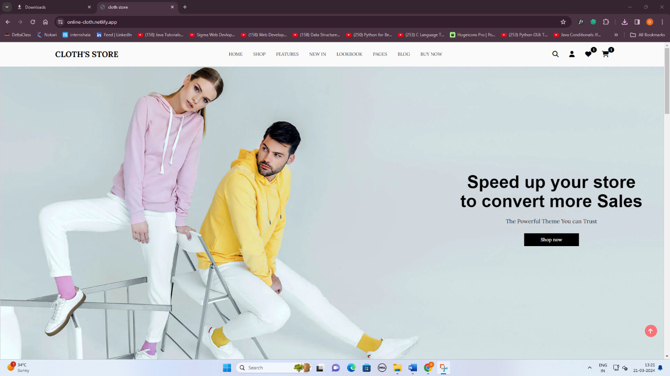

**Footer**

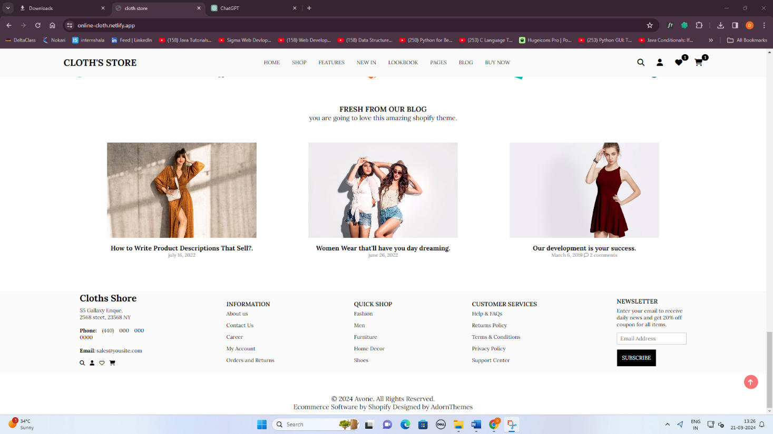

**Cart-Bar**

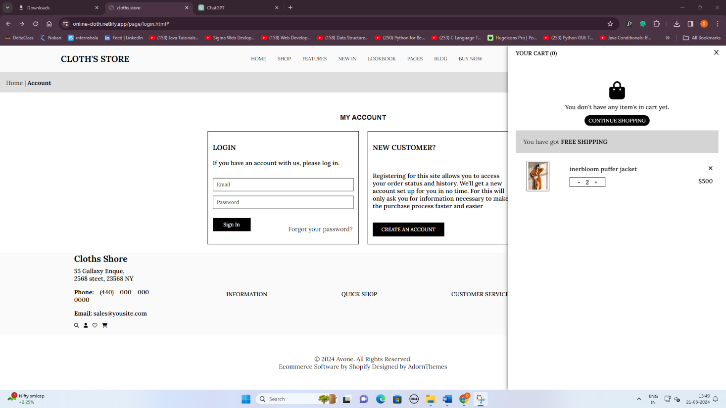

**Filter**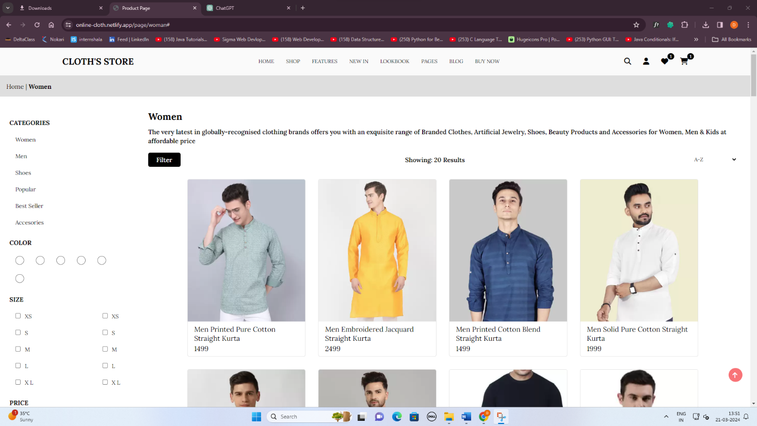

**New-In** 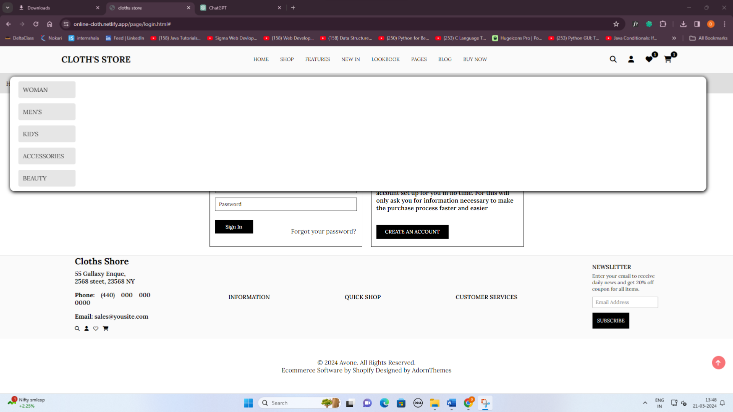

**Sign-In & Sign-Up**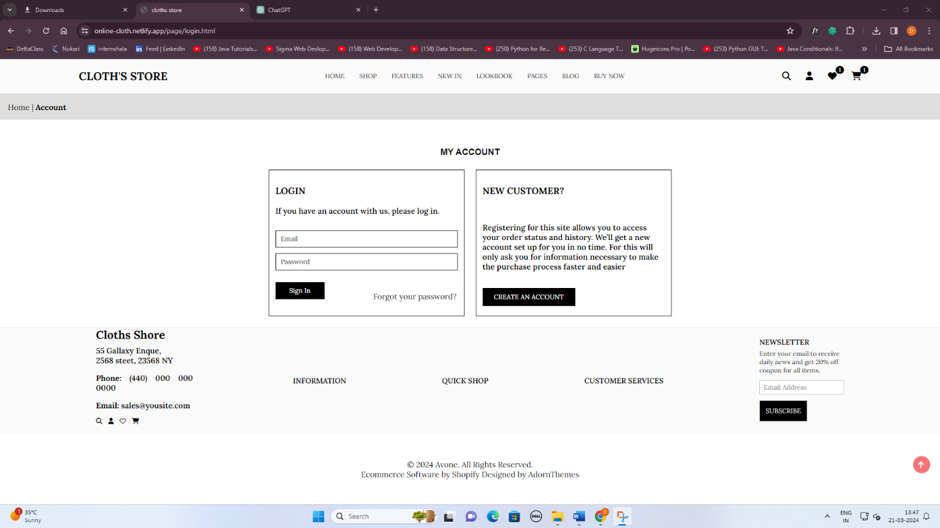

**Wishlist**

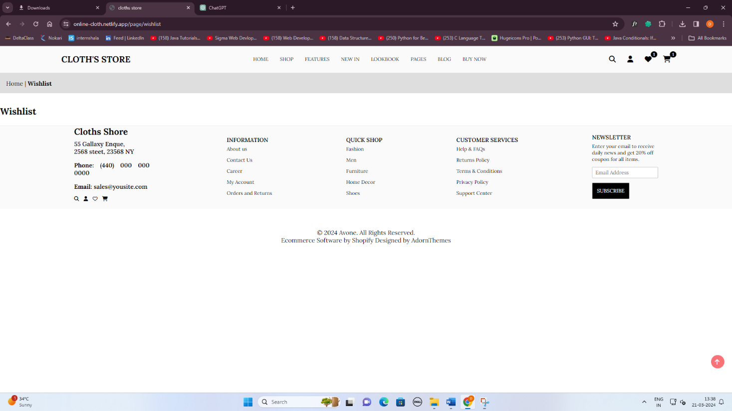

**Conclusion :**

The Cloth Store Management System represents a comprehensive solution for managing an online cloth store efficiently and effectively. Throughout the development process, several key aspects have been addressed, resulting in a robust and user-friendly system.

1. Purpose and Scope:

- The primary objective of the project was to create an online platform that offers a seamless shopping experience for customers while providing essential management tools for store administrators.

- The system allows customers to browse a wide range of products, place orders, and track their purchases, while administrators can manage inventory, process orders, and analyze sales data.

2. Design and Implementation:

- The system's architecture follows a client-server model, with a web-based interface for clients and a server-side application for managing business logic and database interactions.

- User interface design prioritizes usability and responsiveness, ensuring that customers can easily navigate the site and make purchases on any device.

- The database schema is carefully designed to store and organize data efficiently, facilitating seamless interactions between different components of the system.

3. Functionality and Features:

- The system offers a variety of features, including product browsing, search functionality, shopping cart management, and secure checkout processes.

- Customers can create accounts, save favorite items, and receive order status updates via email or notifications.

- Administrators have access to features for managing products, categories, orders, and customer accounts, providing them with the tools they need to run the store effectively.

4. Conclusion:

- In conclusion, the Cloth Store Management System successfully achieves its objectives of providing a user-friendly shopping experience and efficient store management capabilities.

- The system's design and implementation adhere to best practices in web development and database management, ensuring reliability, scalability, and security.

- Moving forward, the project can be further enhanced with additional features, optimizations, and integrations to meet evolving customer needs and business requirements.

Overall, the Cloth Store Management System represents a valuable asset for cloth store owners looking to establish a strong online presence and streamline their operations. By leveraging modern technologies and user-centered design principles, the system helps drive sales, enhance customer satisfaction, and optimize business performance.

Project Reference:

Start Date: 20/01/2024

End Date :20/3/2024

Description: This project is a web-based Cloth Store Management System designed to facilitate online shopping for clothing items. It allows customers to browse a wide range of products, place orders, and manage their accounts. Additionally, administrators can manage inventory, process orders, and analyze sales data through an intuitive interface.

Technologies Used:

- HTML

- CSS

- JavaScript

- jQuery

- PHP

- MySQL

Libraries/Frameworks:

- Font Awesome

- jQuery

Development Tools:

- Code editor (e.g., Visual Studio Code, Sublime Text)

- Web browser (e.g., Google Chrome, Mozilla Firefox)

References:

- Font Awesome: https://fontawesome.com/

- jQuery: https://jquery.com/

- W3Schools (for HTML, CSS, and JavaScript references): https://www.w3schools.com/